Fishbone Diagram Guide
Analyze the Situation

Introduction
A fishbone diagram (also known as an Ishikawa diagram) is a cause and effect diagram that your team can use to brainstorm and organize possible causes of a problem (effect). Fishbone diagrams can help prevent your team from deciding on solutions before considering all possible root causes.

How to Use the Tool
A template for the fishbone diagram is available as a separate tool.
- Briefly identify the problem (effect) in the rounded box at the far right of the diagram. Consider phrasing it as a question (“Why do we have X problem?”) to focus your team on brainstorming root causes of the problem, rather than potential solutions to address it.
- With your team, decide on the cause categories you will use. In healthcare, it is common to use the “5 P’s”:
  - Patients
  - Providers
  - Policies
  - Processes and Procedures
  - Place and/or Equipment
Another common set of categories, especially in manufacturing environments, are the “Six M’s”: machine, method, materials, measurement, man and mother nature.
Pick categories that make the most sense for your organization and problem. If there is a category that is not listed here but is important for your project, feel free to add it.
Once you have decided on the categories you will use, add the category titles to the fishbone diagram template (replacing the “Category” placeholders). Remove any unused branches.
- As a team, identify potential or known causes, and record them along the appropriate diagonal line for each category. The goal is to group the causes in a logical way. If a particular cause seems to belong to more than one group, feel free to add it in each category that makes sense, or in the most applicable category. If you are not sure whether a cause is real (i.e., potential cause instead of known cause), flag it with a question mark.
- Add additional cause lines and branches as required during brainstorming. Consider all lines (bones) of the “fish” and do not focus only on one or two categories.

Example
The following diagram shows an example of a fishbone diagram for a fictitious clinic that would like to reduce its rate of no-shows. Note that in this example, the categories were customized: a “Technology” category was added, as it was considered important for this problem, while “Policies” was not used.

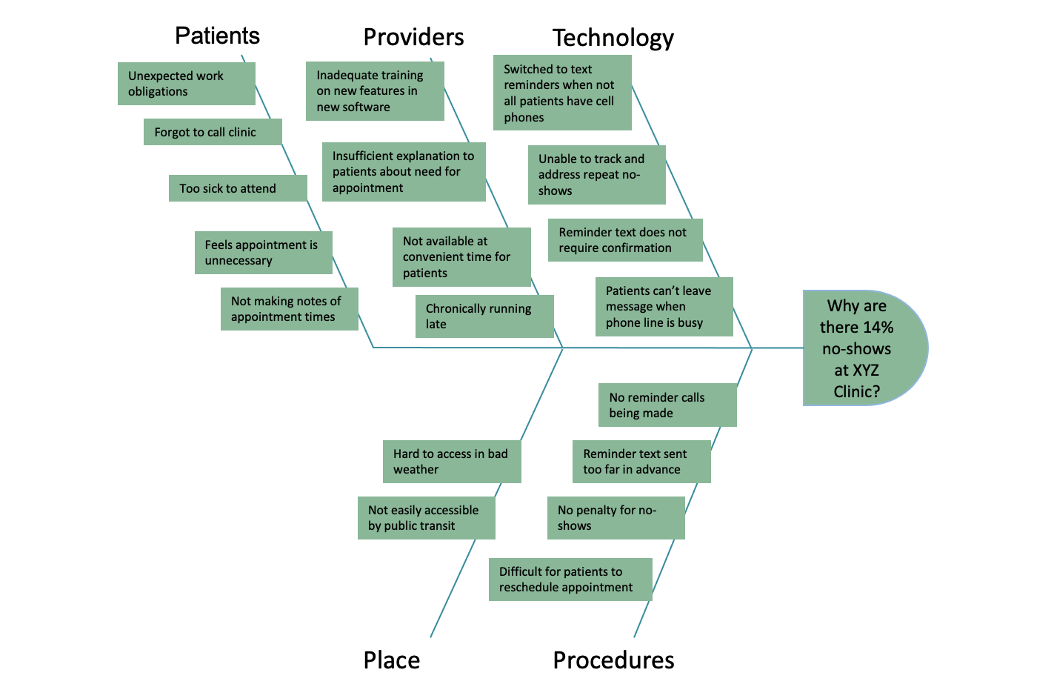

How to Use a Completed Fishbone Diagram
Once your team has completed a fishbone diagram, it can be used to assist you in deciding which cause(s) of the problem to target when you consider potential solutions in the next step of the framework, Test & Trial Improvements.
The following activities will help you focus in on the root causes with the most potential:
- If it is unclear whether a cause is a real contributor to the problem (i.e., it is a potential cause rather than a known cause), collect the data necessary to determine whether this is a true cause. If not, scratch it from your list of causes.
- Use the 5 Whys to drill deeper into any cause that may be of interest. This process may reveal the deeper root cause for that aspect of the problem. Targeting this deeper cause is more likely to be successful than targeting the “symptom.”
- Identify the causes that are not in your power to control within the scope of the project. For example, if a process step must be done a certain way because it is required by a government agency, this may not be a productive path for a QI project. That said, it may be possible to consider a project to mitigate against something that is not within your control. For example, it is human nature to accidentally forget things from time to time. This cannot be controlled, but strategies to cope with this may be possible.
- Identify which of the causes tends to contribute most to your problem. It is ideal if you have, or can obtain, data to verify this. The Pareto chart is a helpful tool for this purpose.
By systematically working your way through the fishbone diagram with these activities, you should be able to identify a root cause (or short list of root causes) that will be a starting point for your discussions on potential solutions.

References
Content for this page was adapted from Health Quality Ontario and from Vanguard Communications.

