PDSA Template

Test & Trial Improvements

Instructions
Each PDSA has four stages, as shown below.
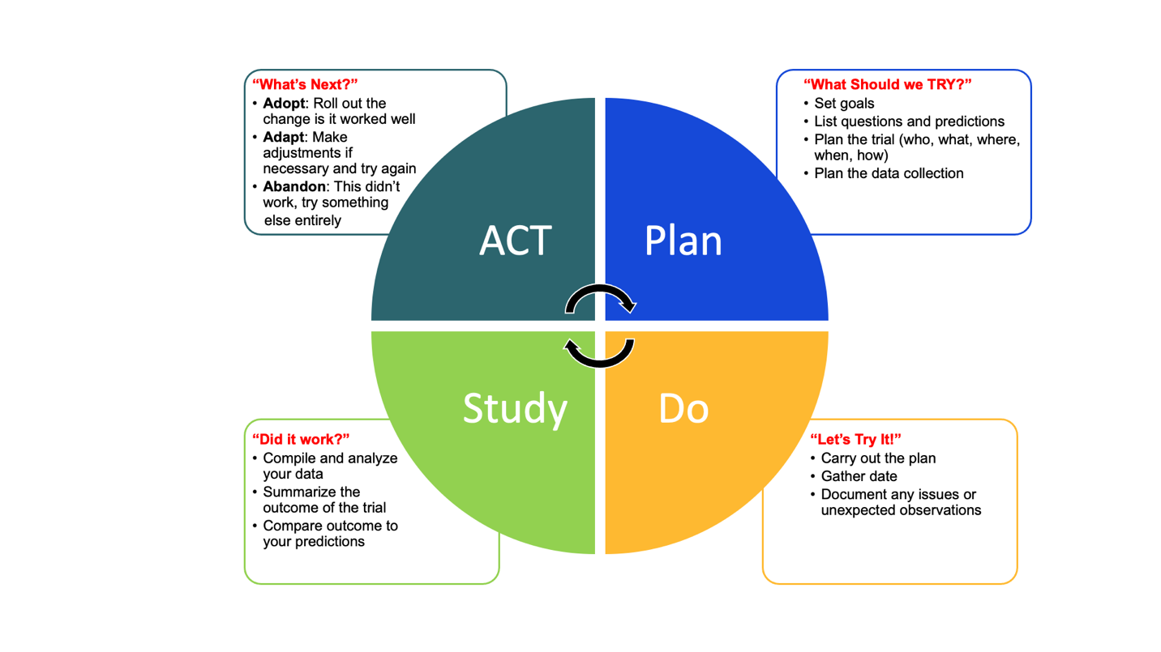
Copy and paste the PDSA table below as many times as needed to cover all the PDSAs your team completes. Each table will provide an overview of a specific PDSA, and together they create a summary of all the solutions and iterations trialed for your project. The text in blue italics are guidance tips and should be deleted when you fill out your own content.
As this is meant to be a summary, the information should be kept short and high-level. You are encouraged to add references or links to more detailed documentation related to your PDSA(s), so that they are available for those looking for more information after reading the summary (including future you, who might have forgotten which documents are which, and where you put them!). This will also ensure that you consider and complete the planning and analysis work that will maximize the chances of success for your project.

Worksheet
Project Title
Project Number (if applicable)
Project Lead

PDSA #  1 | TITLE
Plan | What are we going to test?  Describe in a sentence or two what you are implementing with this PDSA.
Related Documents
Measurement Plan: [replace this text with a link or the name of the file]
Communication Plan: [replace this text with a link or the name of the file]
Do | What did we do?  Describe in a sentence or two what was implemented. Be sure to include when it was done, and the context (who, where).
Related Documents (Optional)
Include links to related documentation, if any. For example, if you have saved pertinent emails to a folder for future reference, you could link to this folder here.
Study | What was the outcome of this PDSA?  What happened? What do your data show after you completed the analysis?
Related Documents
Add references to any documentation compiled during the analysis, e.g., spreadsheets with statistical analysis, survey results, etc.
Act | Next Steps  Based on the results, the team has decided to:  ☐ Adopt ☐ Adapt ☐ Abandon  Reasoning for Decision  Add a short description of why the above decision was made.
Related Documents
After-Action Review: [replace this text with a link or the name of the file]

