Process Mapping Guide
Analysis

Introduction
A process map is a diagram that visually describes the steps and structure of a process. Process mapping can be done at varying levels of detail. High-level process maps may describe key stages of a process without getting into the details of how these stages happen. More detailed process maps can be made of a specific area in the process, resembling a visual representation of a standard operating procedure (SOP) or work instruction.

It is usually a good idea to start with a high-level process map to get a broad sense of the system being described. Subsequent iterations can then be completed to drill deeper into specific areas of the process as needed. Processes are often very complex; getting a map of a large system in very fine detail is likely to be overwhelming, difficult to navigate, and difficult to make decisions from.

This guide introduces the basic structure of process maps, provides tips on how to scope your process mapping exercises, introduces process map variations, and suggests ways to identify opportunities for process improvement using a process map.

Anatomy of a Process Map

Layout
To begin, be sure to set up the pertinent information about the process map, so that the context is understood by those who may be looking at it in the future. This includes:
- The name of the process that is being mapped. Be specific: “Biopsy Process” is better than nothing, but “Imaging Process for Ultrasound-Guided Lung Biopsy” is clearer both for those who will contribute to producing the process map, and those viewing it later.
- The date. This is very important since the process map is a snapshot in time, and the date indicates when this “snapshot” was taken. If the process evolves over time, it is helpful to know what may or may not still be valid.
- The contributors. It is helpful to know who was represented when this map was created, and who to contact (or who else to contact) if an updated map is needed.
- Version number. This is optional, but if your process map is rapidly evolving (e.g., it is being reviewed by a team and multiple versions with corrections are being generated), version numbers are useful in ensuring that team members are all using the same version in discussions.

Shapes
There are many standard shapes that are used in process maps, but high-level process mapping can be done with four simple shapes. These shapes are standard for all process maps, regardless of industry. There are no specific rules for colour-coding; choose a colour scheme that is easy to read.

Rectangles describe a process step. | Diamonds indicate decision points; they usually contain a question. | Ovals indicate start and end points. | Rectangles with a wavy bottom indicate a document produced.

These shapes are then interconnected into a process map with arrow connectors.

The Process Map Template includes examples of each of these four shapes, which you can copy and paste as needed for your process map.

Scoping the Process Map
As mentioned in the introduction, it is important to consider the scope of any process map you create. If your project is small-scale, it may be possible to include all the important details of your process in a single process map. However, it is common that a process being examined for quality improvement is quite complex, and process mapping should be tackled in iterations.

If your process is complex enough that it would require more than around a dozen steps to describe in detail, the following strategy may help narrow the focus without overwhelming the team:
- Start by developing a high-level process map. This is usually about 5-12 major steps in the process, without details on how these steps are accomplished. For example:
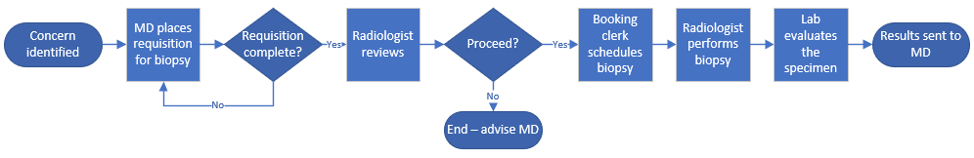
- Get input from the team on the key pain points in the process, i.e., where they may tend to encounter delays, problems, etc. Organize these pain points by process step and add them to the diagram. You can use the pain point “burst” shape for this (included in the Process Map template in the toolkit), or simple boxes in a different colour to annotate your diagram.
- With your process map and pain points, identify section(s) of the process your team would like to map in more detail.
- As needed, develop separate, more detailed process maps for these smaller sections of interest from the high-level process map. For example, continuing from the previous high-level process map for biopsies, if multiple pain points were identified with booking biopsies, your team may decide to sit down with the booking clerks (and anyone else involved) to develop a process map specifically for the booking process.
Process mapping is often iterative. Decide which level of detail and which areas of the process would be helpful for your team to visualize and use that to guide the mapping.

Variations on the Process Map

Swimlane Diagram
A swimlane diagram is a process map that is organized by role. It contains rows or “lanes” that each represent a role or person involved in the process. The blocks in the process are connected by arrows as usual, but each block is placed in the lane of the role that is performing that step. See example below.

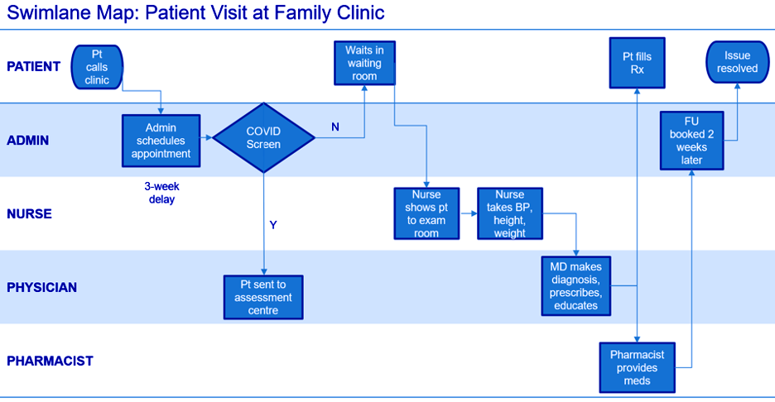

Future State Map
A future state map is a process map that represents an improved version of the current process. It may not necessarily represent the ideal process, but it should represent how you might want the process to look at the end of your project.
To develop a future state map, evaluate your current process map to determine whether there are opportunities to improve it. See the section Evaluating a Process Map below for tips on finding potential improvements in your current process.

Steps to Running a Process Mapping Session
- Identify and assemble a team to work on the Process Map. This should include representatives from any role or area that performs or assists with the process, i.e., those who know the process well and first-hand.
- Use a facilitator that is neutral to the process.
- Identify the first and last steps of the process to be mapped. This should ideally be done prior to sending out the invitation to the mapping session, so that the participants know what to expect, and so that the right people are involved. This also gives a sense of how much detail should be included in the process steps.
- Set up the mapping tools. The preferred way of doing this is by setting up a large sheet of kraft paper or flip chart paper, then jotting the process steps onto sticky notes that can be moved around as needed. This step can also be done in PowerPoint or Visio if the sticky note method is not possible.
- Identify (map) the remaining steps that form the process. It is possible that the steps may not be clear, or that different people do certain things in different ways. Do your best to get the “usual” process and make note of exceptions or differences. See the section Evaluating a Process Map below for guidance on navigating unclear or variable processes.
- Map the actual process as it is—not as it is “supposed to be.” After the process map is complete, where possible it is recommended to go to where the process is done and confirm that the steps are happening as described on the diagram.
- When the mapping session is over, transcribe the process map into a software tool like PowerPoint or Visio, and send it to the group for review.

Tips
- While developing your process map (whether on paper or digitally), hold off on connecting the boxes with arrows until the end. During a mapping session, it is common for boxes to get inserted into the middle of the process, rearranged, or combined as the discussion progresses among the team members. Adding the arrows last will save the hassle of reconnecting all the arrows when this happens. Similarly, if mapping in person with sticky notes on kraft or flip-chart paper, do not draw the arrows directly onto the support paper, in case the sticky notes need to be moved around.
- A current state process map should indicate only how things are. If the discussion turns to suggesting solutions (such as, “This step always takes way too long – it could be done in half the time if only they let us do XYZ!”), note the potential solution(s) on the side for future consideration, then guide the conversation back to discussing the current situation.

Evaluating a Process Map
Once your team has completed the process map(s) needed to visualize the process that the QI project aims to improve, the next step is to evaluate it to identify opportunities for improvement.

Solidifying a Process Map
One outcome of the process mapping exercise may be that it is either unclear what the process is, or there are multiple versions of the process, e.g., different people doing the same thing in different ways.
Pay attention to the following words, as they may flag inconsistencies in the process:
- Sometimes
- It depends
- Maybe
- Possibly
- Except
- If (followed by a variable circumstance, such as who is on shift)
- Kind of
- We ask so-and-so what to do next

Also pay attention to body language during a mapping session. Sometimes the “official” process is explained with a tone of frustration or laughter, indicating that something “should” happen one way but doesn’t or can’t happen in that way. If you see this, ask follow-up questions to determine whether there are pain points or inconsistencies under the surface.
If you do run into inconsistencies or nebulous areas of the process, do your best to indicate the normal process and note the exceptions. If there are a couple of distinct processes, it may be worth mapping them out separately and comparing them.
Regardless of how you document it, inconsistent processes are a common source of confusion, delay, inefficiencies, and error, and should be addressed where possible with improvement projects.

Identifying Opportunities for Improvement Using Your Process Map
When you meet with your team to evaluate the process map, use these questions to identify opportunities to improve the process.
- Are there unnecessary steps? Can any of these steps be removed?
A “waste walk” would be a helpful input to this process. Have your team determine if your process includes any “overproduction” or redundant work. Examples:
  - A step that produces output (e.g., a document or result) that is not used anywhere else or is irrelevant to downstream decisions.
  - A step whose output is later undone. In this case, both the “do” and “undo” parts of this process may be unnecessary.

- Can steps be combined?
Consider whether any steps could be done together. Example:
  - Two patient visits that could be replaced with a single visit (e.g., could separate lab testing and imaging be coordinated into a single visit that includes both?)

- Can steps be done in a different order?
Consider whether any steps could be reversed or done in a different order. Example:
  - A clerk processes the documentation for a procedure (which takes several days), then calls the patient to book the procedure (which will also be several days away). Can the booking happen first, then the document processing, so that the document processing happens during the patient’s wait time, and does not delay the booking?

- Can steps be done elsewhere?
Consider whether any steps could be done elsewhere. This is a key question in allowing steps to be done in parallel rather than in sequence, which may reduce overall process time and/or variability in process time. This is especially important if your project is targeting a resource bottleneck, such as OR time or time on imaging equipment like a CT scanner. Reducing the time your process requires from the bottlenecked resource is often key. Examples:
  - For anesthesia procedures that do not necessarily need to be done in the OR, complete these procedures in another room while the previous case is being completed in the main OR.
  - Virtual visits may reduce pressure on clinics that may be limited by space.

- Can steps be done in parallel instead of sequentially?
This question is closely linked to the previous question of space. However, it is also possible to see if there are opportunities to do steps in parallel independent of location. To do this, review all sequential steps and identify their dependencies. i.e., ask, “Is the output of step X required as the input for step X+1?” If not, it may be possible to do these steps in parallel. Examples:
  - Consider splitting independent tasks among multiple staff.
  - Identify whether there are opportunities to operate more like a race car pit crew. (See this video for an example of how a Formula 1 pit stop was reduced from 25 seconds (in 1981) to 4 seconds in 2019.)

- Can steps be done by someone else more efficiently or effectively?
Consider whether any steps could be done by someone else to improve efficiency. To identify these opportunities, look at who (person, clinic, organization) is performing a step and ask, “Is this part of their core competency?” or “Are we reinventing the wheel?” Examples:
  - Options may exist to outsource certain specialized tasks to third party organizations: e.g., medical device reprocessing, repair, software development, etc.
  - A clinical role performing admin tasks, or vice versa. Aligning tasks to core competency is likely to improve the process.

Once your team has thought through these questions and identified opportunities for improvement, you should have a helpful resource to identify potential solutions. Consider creating a Future State process map and using this information to guide your work in the Test & Trial Improvements stage of the project.

