Run Chart Guide
Analyze the Situation

Introduction
A run chart is a type of graph that displays results collected repeatedly over time. Run charts make process performance visible over time. They show how much variability occurs in the process performance and whether an improvement or intervention has resulted in a change in the performance.

A run chart uses statistical rules to identify “special cause” events when process performance has changed. This could be due to an improvement or could be an outlier or it could be another trend due to something else that happened requiring correction. When variability does not meet the “special cause” rules then that variability is “common cause” and is routine or expected within that process.

What is a “Run”?
A run is a group of one or more points on one side of the median. In other words, whenever the line connecting the points crosses the median, this starts a new run. The chart below has 20 points and 9 runs, which are identified with numbers.

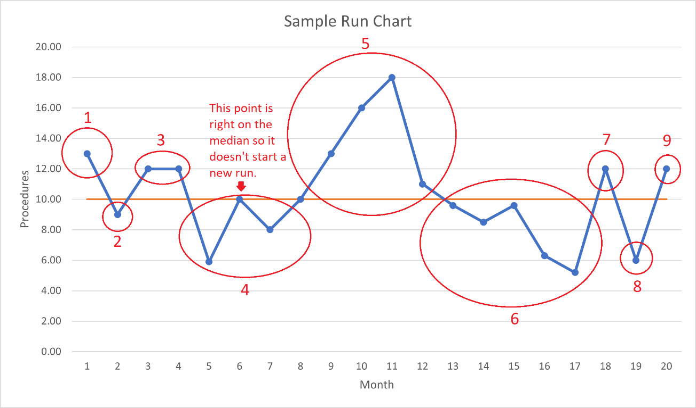
Points right on the median can be excluded when counting runs. If a point is on the median and both the previous and the next points are on the same side, these are all part of the same run (for example, in Run 4 of the diagram). However, if there is a point right on the median and the points before and after are on different sides of the median, this starts a new run (for example, the transition between Runs 4 and 5 on the diagram).

Being able to count the number of runs in your chart will be important for determining whether your process variation is normal and random, or whether it is exhibiting any special cause variation. We will revisit this in the Run Chart rules.

How to Build a Run Chart
- Identify the variable you would like to plot. This should be a quantitative (numerical) variable that can be plotted on a graph. Examples: number of visits to your clinic per day, average response time for a particular event, wait times for a bed, room turnaround time, etc.
- Set up your chart. Be sure to include a title and axis labels so it’s clear what is being plotted and what the time frame is. It is also useful to include an arrow that indicates the favourable direction, i.e., the direction you would like the metric to shift toward with your QI initiative. See the example run chart at the end of this section.
- Plot your data on the run chart.
  - Time is on the X (horizontal) axis from left to right, and your variable values are on the Y (vertical) axis.
  - Each data point on the graph is one measurement or sample.
  - Consider the most appropriate time interval for the X axis (days, weeks, months, etc.). Factors to consider when making this decision are:
    - Are the data already automatically collected at a certain interval?
    - How much work is it to collect the data, vs. how frequently do we need to collect the data for it to be useful in analysis?
    - How frequently do we have opportunities to collect the data? (e.g., are the measurements related to an infrequent event or occurrence?)
- Find the median of your baseline data. In other words, this is how your process is performing before you make any changes with a QI project. If you haven’t yet started your QI project, the baseline data will probably include all the data you have plotted at this point.
  - Ideally, the baseline median is calculated using at least 10 data points.
  - Plot the median on the graph.
- If you have already tried some QI initiatives along the way, such as a PSDA, annotate the graph with the changes or interventions that happened.
- Use the run chart rules to determine whether there are any statistically significant changes in your process.
  - If any of the rules are met, those events are said to be “special cause” and something has changed in the process – either an improvement from your QI initiative (this is what you are hoping for!), or some other impact to the process. Note that these special causes can be favourable or unfavourable, so it is not necessarily the case that “breaking a rule” is a bad thing. It simply indicates the change is unlikely to be due to random chance.

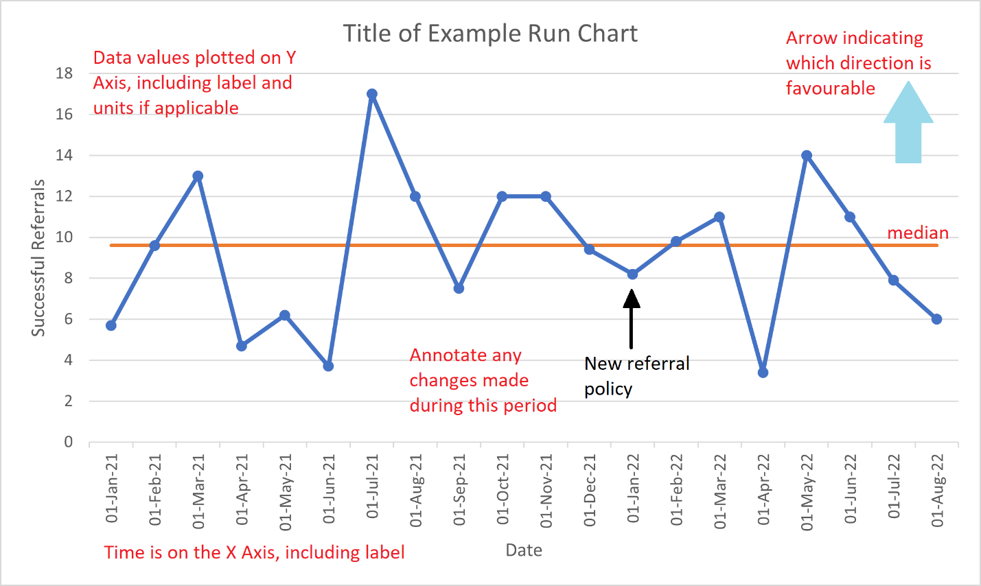

Run Chart Rules
Run chart rules are based on probability and statistics. If at least one of the rules applies to a run chart, the pattern identified is probably not due to random chance (common cause); instead, it is probably due to something unusual that happened – a “special cause”. This could be an improvement (e.g., a QI initiative or PDSA that you are trialing), or it could be something else that inadvertently changed how the process was running. If the cause is not already known, the team should investigate this until the cause is known.

There are four run chart rules for determining the presence of special cause variation. These are described in the remainder of this guide.

Rule 1: A Shift (Six or more consecutive points above or below the median)
If there are 6 or more consecutive points that are all above or all below the median, there is likely a special cause—a specific reason—for this, beyond just random chance.

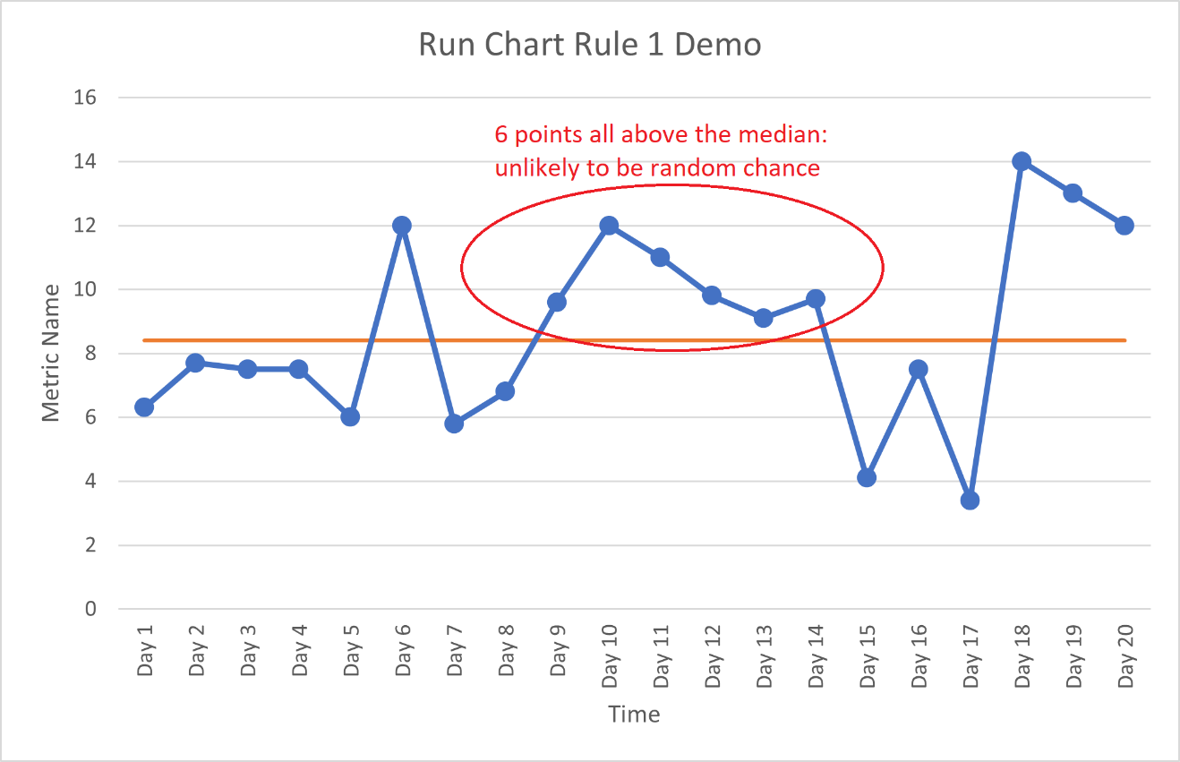

Ignore any points that fall right on the median; these are not counted towards the total. In the following run chart, there is a shift which involves 7 points below the median. There is an 8th point which was not included in the count because it is on the median. As long as there is no crossing over the median, these are all part of the same run.

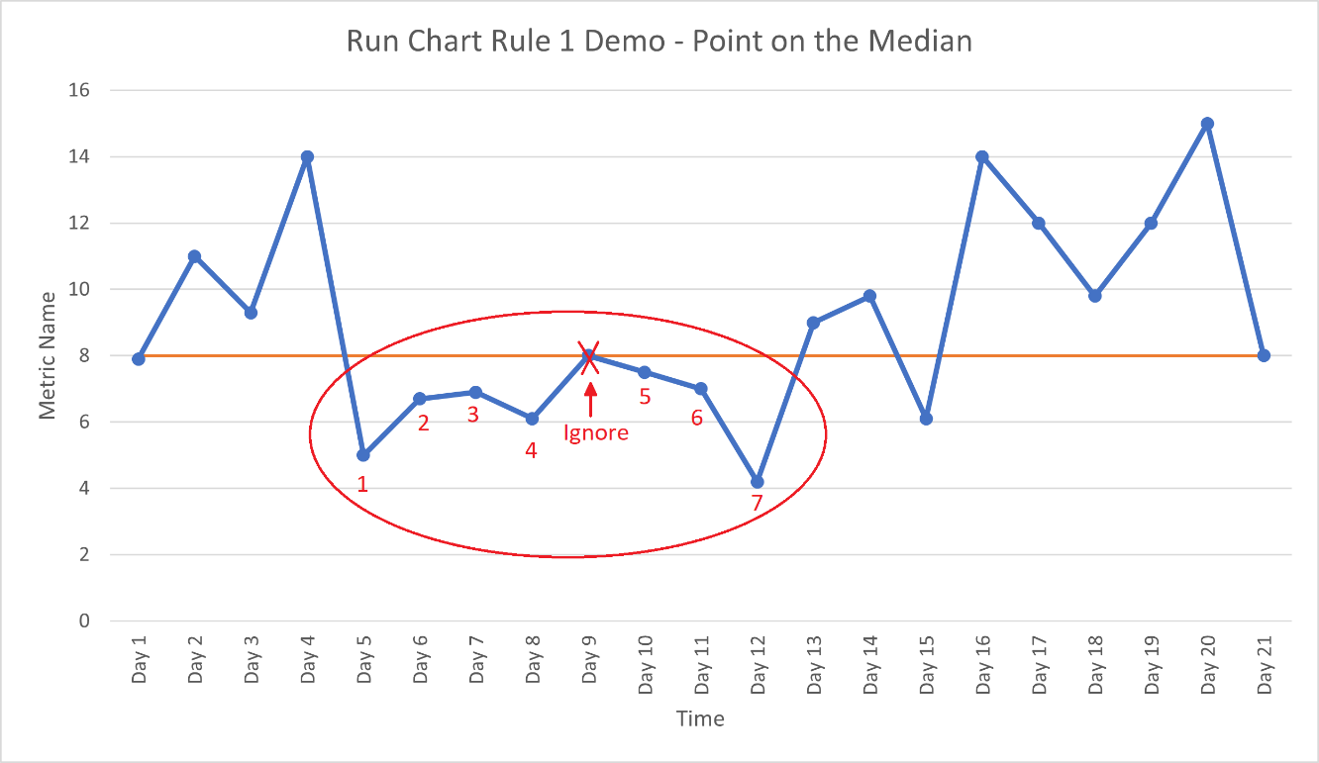

Rule 2: A Trend (Five or more consecutive points all increasing or decreasing)
If there are 5 or more consecutive points that are all part of an increasing or decreasing trend, this is also an indicator that there is likely to be a special cause involved. There are a few notes to keep in mind with this rule:
- It does not matter whether this trend crosses the median, as long as the trend is present.
- Include all points that are involved in the trend, i.e., the middle points as well as both end points.
- Ignore points that are the same as a previous point. Notice that this is different from Rule 1 (which is to ignore points on the median).
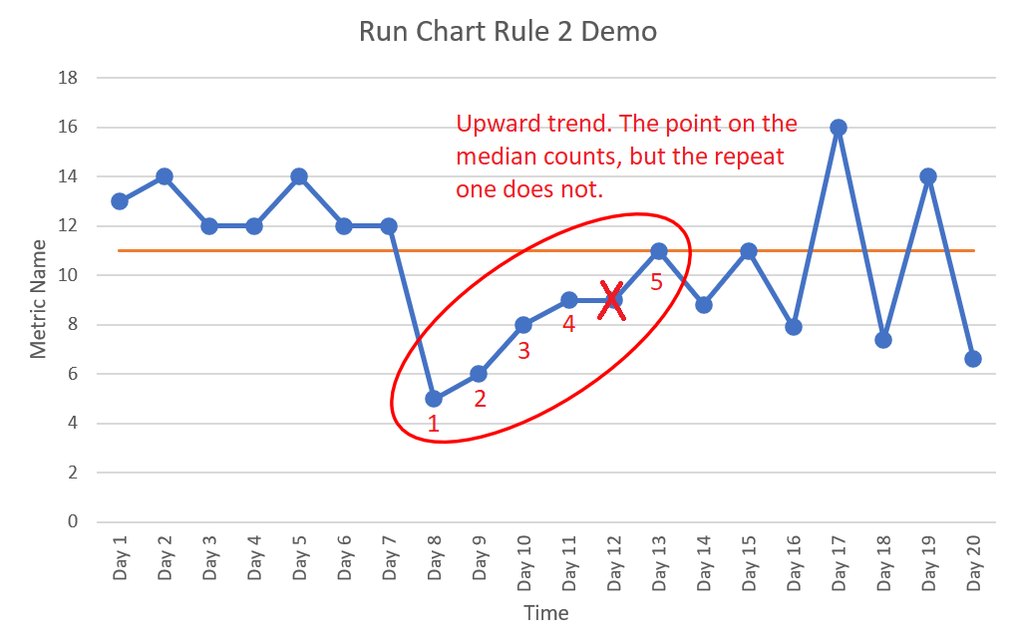
(Notice also that the above run chart breaks Rule 1 twice. Can you spot where this happens?)

Rule 3: Too few or too many runs
This rule indicates the minimum and maximum number of runs you could expect to have if the variation is random (common cause).
This rule is the most subtle of the four since there may not always be an obvious pattern in the run chart, even when this rule might be indicating that there is special cause variation.
When the process is running with common cause (random) variation, the expectation is that the process will move back and forth across the median with reasonable frequency—not too frequently, nor too seldom. Either one of these (too frequent or too few crossings of the median, i.e., too many or too few runs) indicate something other than random variation is happening.
Run tables indicate the range of expected number of runs given the number of points in your chart that are not on the median. Points on the median are excluded from the count since they cannot make or break a run, as described earlier in this guide. An example of this table is included in the Appendix on page 10.
To check this rule, complete the following steps:
- Plot your run chart.
- Determine the number of runs in your chart. (See the “What is a ‘Run’?” section for further information.)
- Determine the number of points on your chart that are not on the median.
- Find the row on the table that corresponds to the number of points not on the median.
- Go across the table to the second and third columns, which indicate the minimum and maximum number of runs that would be expected if the process was operating with common cause (random) variation.
If you have fewer runs than the minimum, or more runs than the maximum, you likely have special cause variation in your process. If this happens, and the cause is unclear, it is worth investigating why this is the case so this can be accounted for when determining which QI initiatives to implement.
As an example, here is the run chart we saw earlier when explaining the concept of runs:
This chart has 20 points, of which one is on the median, leaving 19 points that are not on the median. As shown, it has 9 runs. The following row in the table from the Appendix is applicable to this chart:
Number of points on the chart that do not fall on the median | Lower Limit  (Fewer runs indicate non-random behaviour) | Upper Limit  (More runs indicate non-random behaviour)
19 | 6 | 15
A process with random variation and 19 data points should have between 6 and 15 runs. This run chart has 9, which is within these limits, so the amount of variation in this chart is likely common cause rather than special cause. (However, there is another rule that this run chart breaks – can you spot it?)
In the next run chart, there are 22 data points that are not on the median, and from the table, the minimum number of runs we would expect is 7 (with a maximum of 17). At first glance, there is no pattern that stands out in this chart. However, when counting the runs, there are only 6 runs, as shown. Since the minimum we’d expect by random chance would be 7, it appears that there is some form of special cause variation influencing the behaviour of this process.
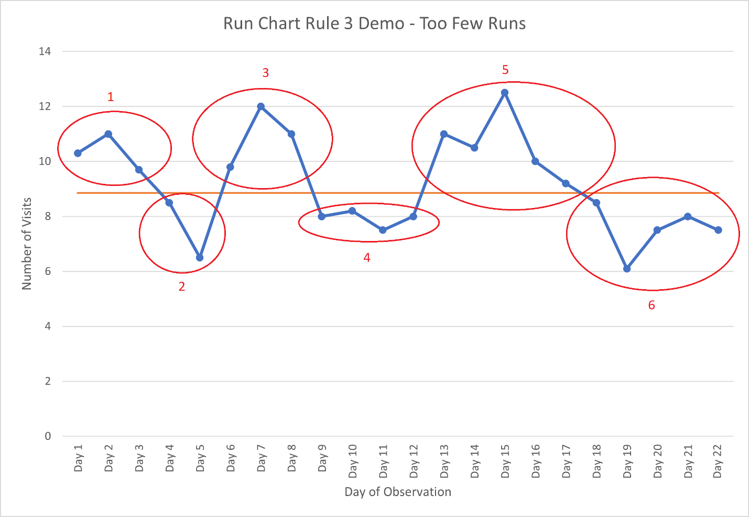

Rule 4: Astronomical point
This is a point that is very different or unusual compared to the other points in the chart. Unlike with control charts, where the control limits will help with flagging astronomical points, run charts do not have control limits. An astronomical point can be unusually high or unusually low, and will typically be quite obvious even at first glance. However, if it is uncertain whether a point is astronomical or not, it may be worth noting and discussing with your team, to see if there was a known cause for the unusual point.
In the following chart, there are two astronomical points: one that is much lower than the typical process, and one that is much higher.
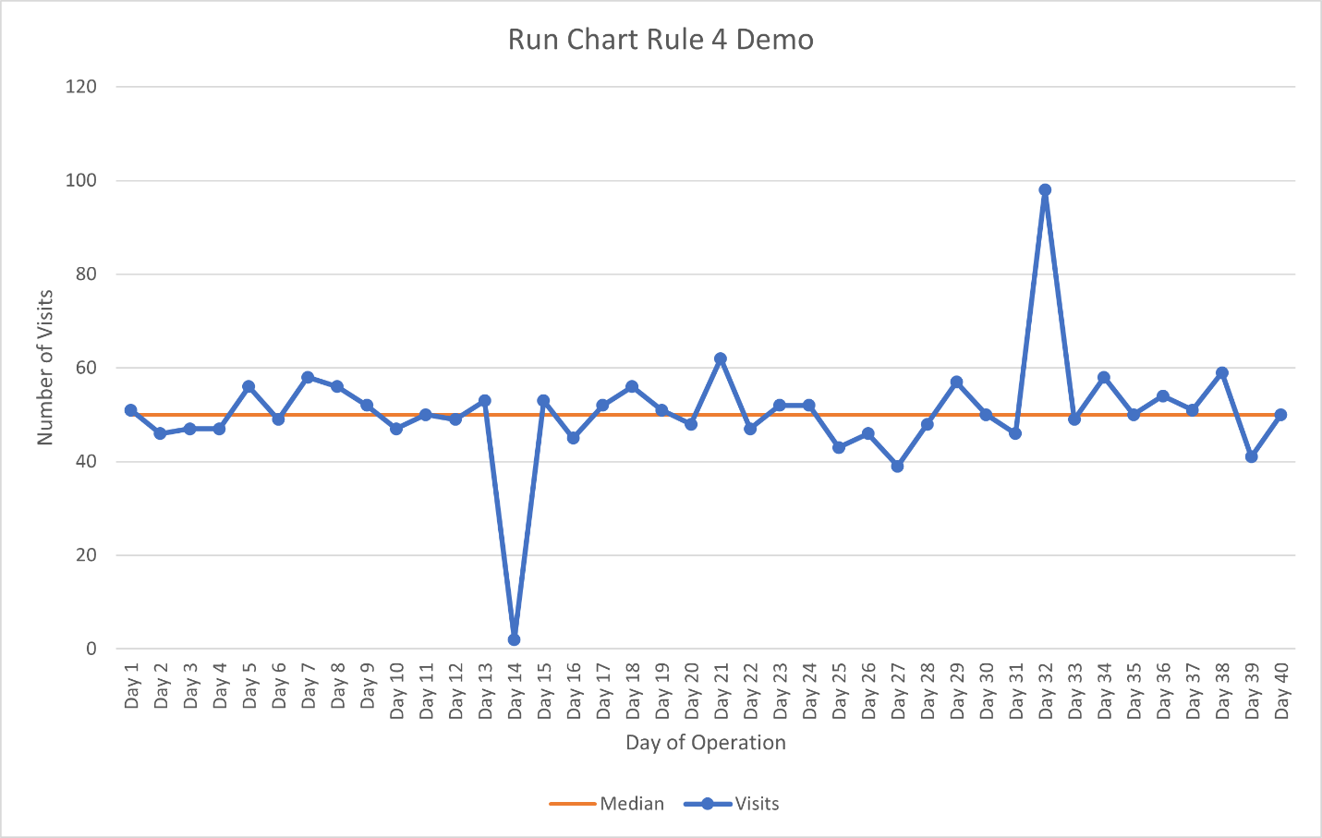

Run Chart Rule Summary
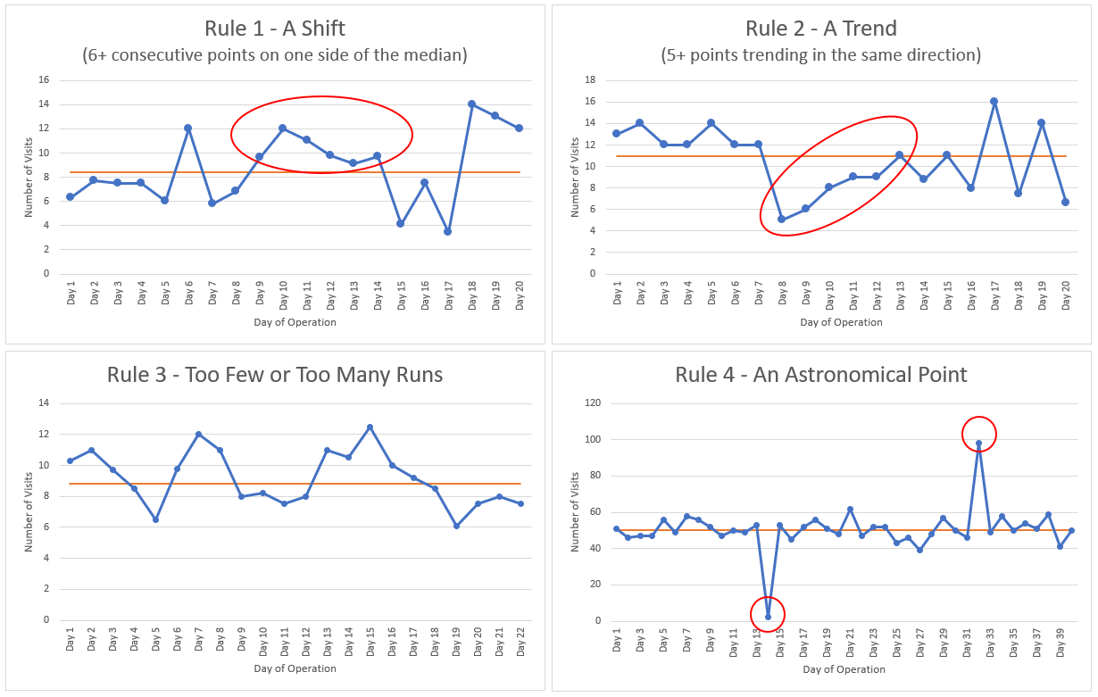

Appendix: Table for Rule 3 – What Constitutes Too Few or Too Many Runs on a Run Chart?

Number of points on the chart that do not fall on the median | Lower Limit  (Fewer runs indicate non-random behaviour) | Upper Limit  (More runs indicate non-random behaviour)
10 | 3 | 9
11 | 3 | 10
12 | 3 | 11
13 | 4 | 11
14 | 4 | 12
15 | 5 | 12
16 | 5 | 13
17 | 5 | 13
18 | 6 | 14
19 | 6 | 15
20 | 6 | 16
21 | 7 | 16
22 | 7 | 17
23 | 7 | 17
24 | 8 | 18
25 | 8 | 18
26 | 9 | 19
27 | 10 | 19
28 | 10 | 20
29 | 10 | 20
30 | 11 | 21
31 | 11 | 22
32 | 11 | 23
33 | 12 | 23
34 | 12 | 24
35 | 12 | 24
36 | 13 | 25
37 | 13 | 25
38 | 14 | 26
39 | 14 | 26
40 | 15 | 27
41 | 15 | 27
42 | 16 | 28
43 | 16 | 28
44 | 17 | 29
45 | 17 | 30
46 | 17 | 31
47 | 18 | 31
48 | 18 | 32
49 | 19 | 32
50 | 19 | 33
This table is adapted from the calculations in Swed FS, Eisenhart C. “Tables for testing randomness of grouping in a sequence of alternatives.” Ann Math Stat 1943; 14:66-87. This table also appears in Provost L, Murray S. The Data Guide: Learning from Data to Improve Health Care. Associates in Process Improvement and Corporate Transformation Concepts; 2010.

